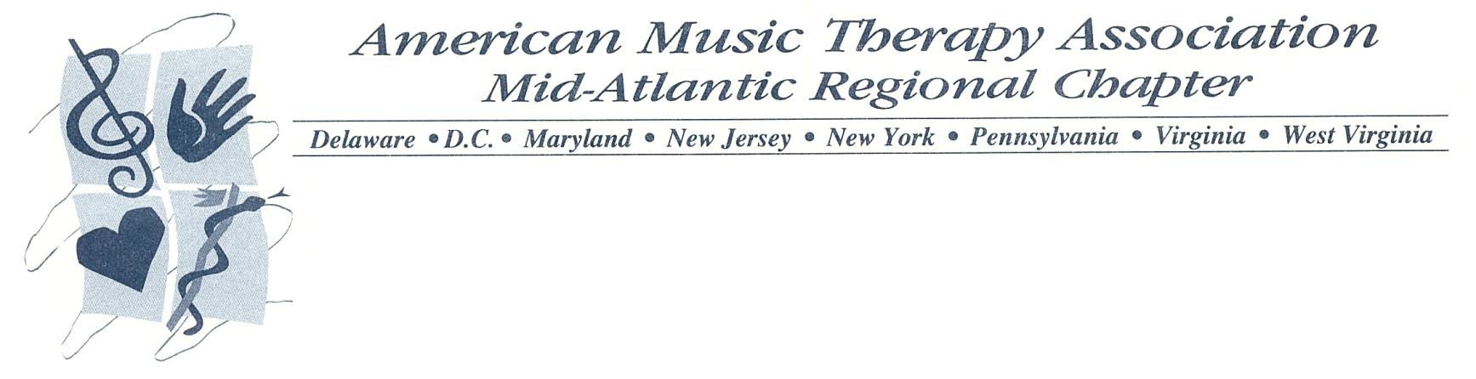

MARAMTS Spring Business Meeting
March 20, 2015
Regional Conference, Ocean City, MD

- Opening Procedures
  - Call to Order: L. Everhart, MARAMTS President at 11:18AM
    - Temple University motions. Marywood University seconds.
  - Roll Call: D. Abourafeh, MARAMTS Secretary
    - Officers
      - L. Everhart, President – Present
      - E. Bligh, President-Elect – Present
      - Q. Thomas, Vice President – Not Present
      - A. Erdman, Parliamentarian – Present
      - D. Abourafeh, Secretary – Present
      - B. Pantalena, Treasurer – Present
      - S. Sullivan, Government Relations Chair – Present
      - C. Loretto, Student Affairs Advisor – Present
    - Schools
      - Drexel University* - 0/1
      - Duquesne University – 13/13
      - Elizabethtown College – 38/38
      - Howard University* - 0/1
      - Immaculata University – 18/21
      - Marywood University – 13/19
      - Molloy College – 8/8
      - Montclair State University – 5/11
      - Nazareth College – 23/23
      - New York University* - 0/1
      - Radford University – 3/4
      - Seton Hill University – 2/40
      - Shenandoah University – 18/30
      - Slippery Rock University – 20/23
      - SUNY Fredonia – 9/11
      - SUNY New Paltz – 3/5
      - Temple University – 22/26
  - Review Robert’s Rules: A. Erdman, Parliamentarian
  - Approval of the agenda
    - Motion to approve the agenda. Elizabethtown College motions. Duquesne University seconds.

- Budget: Brooke Pantalena, Treasurer
  - Approve the Budget
  - Questions?
  - Motion to skip budget because it was approved during first business meeting – Nazareth College Motions. Shenandoah University seconds.

- Government Relations Chair: S. Sullivan, Government Relations Chair
  - Updates on Youtube Channel and RATR
    - 1 Video will be updated in next few days
  - 2/3 of what schools spoke about in school report WAS advocacy
    - Make sure to send video to be put on Youtube channel

- By-Laws: Abigail Erdman, Parliamentarian
  - Approve changes to By-Laws
    - Article V, Section 1-7
    - Article V, Section 3
    - Article V, Section 5
    - Article VI, Section 1
    - Article XII, Section 1
      - Motion to vote on the bylaws. Elizabethtown College motions. Slippery Rock University seconds.
      - All in favor of these changes say I
        - All say I. None oppose. None abstain.

- Executive Board Nominations/Elections
  - Any additional nominations
    - President
      - Motion to open the floor for nominations – Nazareth College motions. Shenandoah University seconds.
      - Nomination
        - E. Bligh
      - Motion to close the floor for nominations – SUNY New Paltz motions. Seton Hill University seconds.
    - President-Elect
      - Motion to open the floor for nominations– SUNY Fredonia motions. Seton Hill University seconds.
      - Nomination
        - Andrea Schaertel
        - Anne O’Rourke
      - Motion to close the floor for nominations – Radford University motions. Slippery Rock University seconds.
    - Vice President
      - Motion to open the floor for nominations – SUNY Fredonia motions. Elizabethtown College seconds
        - Tara O’Brien
        - Angela LoMonte
        - Megan Neil
      - Motion to close the floor for nominations – Marywood University motions. Montclair State University seconds.
    - Parliamentarian
      - Motion to open the floor for nominations – Marywood University motions. Radford University seconds.
      - Nominations
        - Allison Broaddrick
        - Megan Neil
      - Motion to close floor for nominations – Shenandoah University motions. Duquesne University seconds.
    - Secretary
      - Motion to open the floor for nominations – Elizabethtown College motions. Marywood University seconds.
      - Nominations
        - Andrea Schaertel
        - Meghan Smith
      - Motion to close the floor for nominations – Temple University motions. Marywood University seconds.
    - Treasurer
      - Motion to open the floor for nominations– Seton Hill University motions. Radford University seconds.
        - Katie Patterson
        - Amanda Montera
      - Motion to close the floor for nominations – SUNY Fredonia motions. SUNY New Paltz seconds.
    - Government Relations Chair
      - Motion to open the floor for nominations – Shenandoah University motions. Temple University seconds.
      - Nominations
        - Amara May – Withdraw nomination
        - Stephanie McDonald
        - Cody Thompson
        - Sophia Salvatore
      - Motion to close the floor for nominations – Molloy College motions. Slippery Rock University seconds.
    - Student Affairs Advisor
      - Motion to open the floor for nominations – Temple University motions. Duquesne University seconds.
      - Nominations
        - Conio Loretto
      - Close the floor the floor for nominations – Elizabethtown College motions. Slippery Rock University seconds.
  - Election Speech’s (1 minute)
  - Voting for new EB
    - Ballots counted while meeting continues. Newly elected board will be elected later in meeting

- Staying in Contact: D. Abourafeh
    - Social Media - Stay Connected!
    - Facebook
      - MARAMTS Students
      - MARAMTS Chapter Representatives
      - The Mid-Atlantic Region of the American Music Therapy Association
    - Twitter
      - @MAR_AMTS
      - 136 Followers - Let’s improve numbers!
    - Instagram
      - MAR_AMTS
      - 39 Followers - Increase Followers!

- Chapter Representative
  - Communication
    - Review of Duties
    - Any questions?
  - Contact Information Needed
    - New Chapter Representatives
    - New Club President
    - New Club Advisor/Chairperson needed
    - Outstanding Chapter Representative Awarded to…
      - Emily Mountain from Elizabethtown College

- Thank you/Goodbye Speech from President
  - Thanks MARAMTS Executive Board, Chapter Representatives, and all students

- Conferences
  - Passages 2015
    - Seeking a school or internship site that is interested in hosting
      - Get in contact with C. Loretto if you are interested
    - Email will be sent to every school in MAR asking for their input
  - AMTA Conference 2015: “Music Therapy: A Continuum of Growth”
    - Thursday, November 12 through Sunday, November 15
    - Kansas City, Missouri

- Door Prizes

- MARAMTS Executive Board 2015-2016
    - President – Elizabeth Bligh
    - President-Elect - Andrea Schaertel
    - Vice-President - Megan Neil
    - Parliamentarian - Allison Broaddrick
    - Secretary - Meghan Smith
    - Treasurer - Amanda Montara
    - Government Relations Chair - Cody Thompson
    - Student Affairs Advisor - Conio Loretto

- Adjournment
  - Motion to adjourn the meeting at 12:18PM. Elizabethtown College motions. Marywood University seconds.

